Name: Harshalk

Std: TYBSCIT

Roll no: 16

Subject: DMBI

(Practical No 5)

Signature:

Practical 5A – Import the data warehouse in Microsoft Excel and create Pivot Table to perform Data Analytics

Open Microsoft Excel, go to Data, in From Other Sources select From Analysis Services.

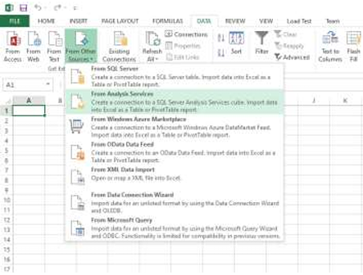

Enter your Server name and click on Next.

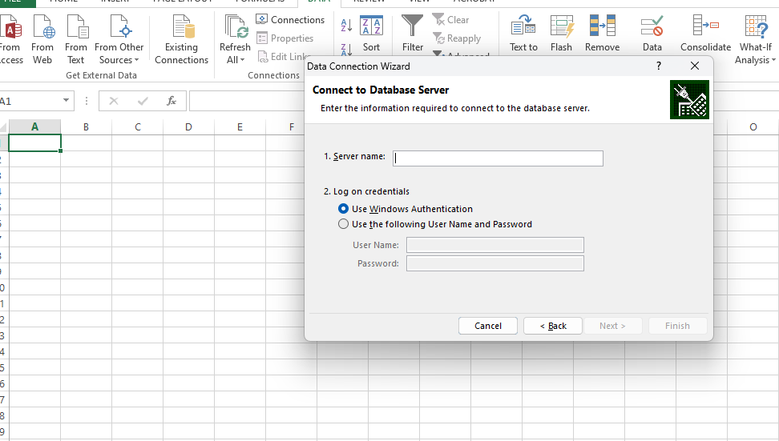

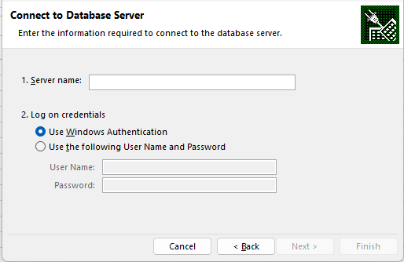

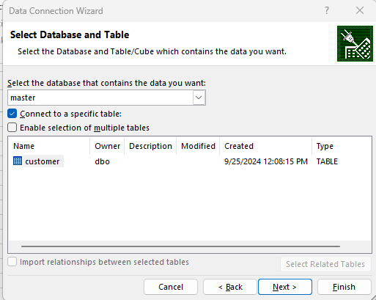

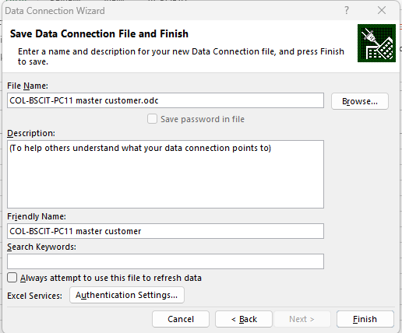

Insert a Pivot Table.

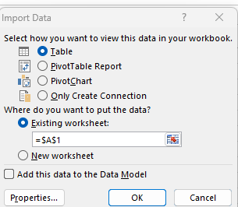

Select the row labels for the pivot table.

Select the column labels for the pivot table.

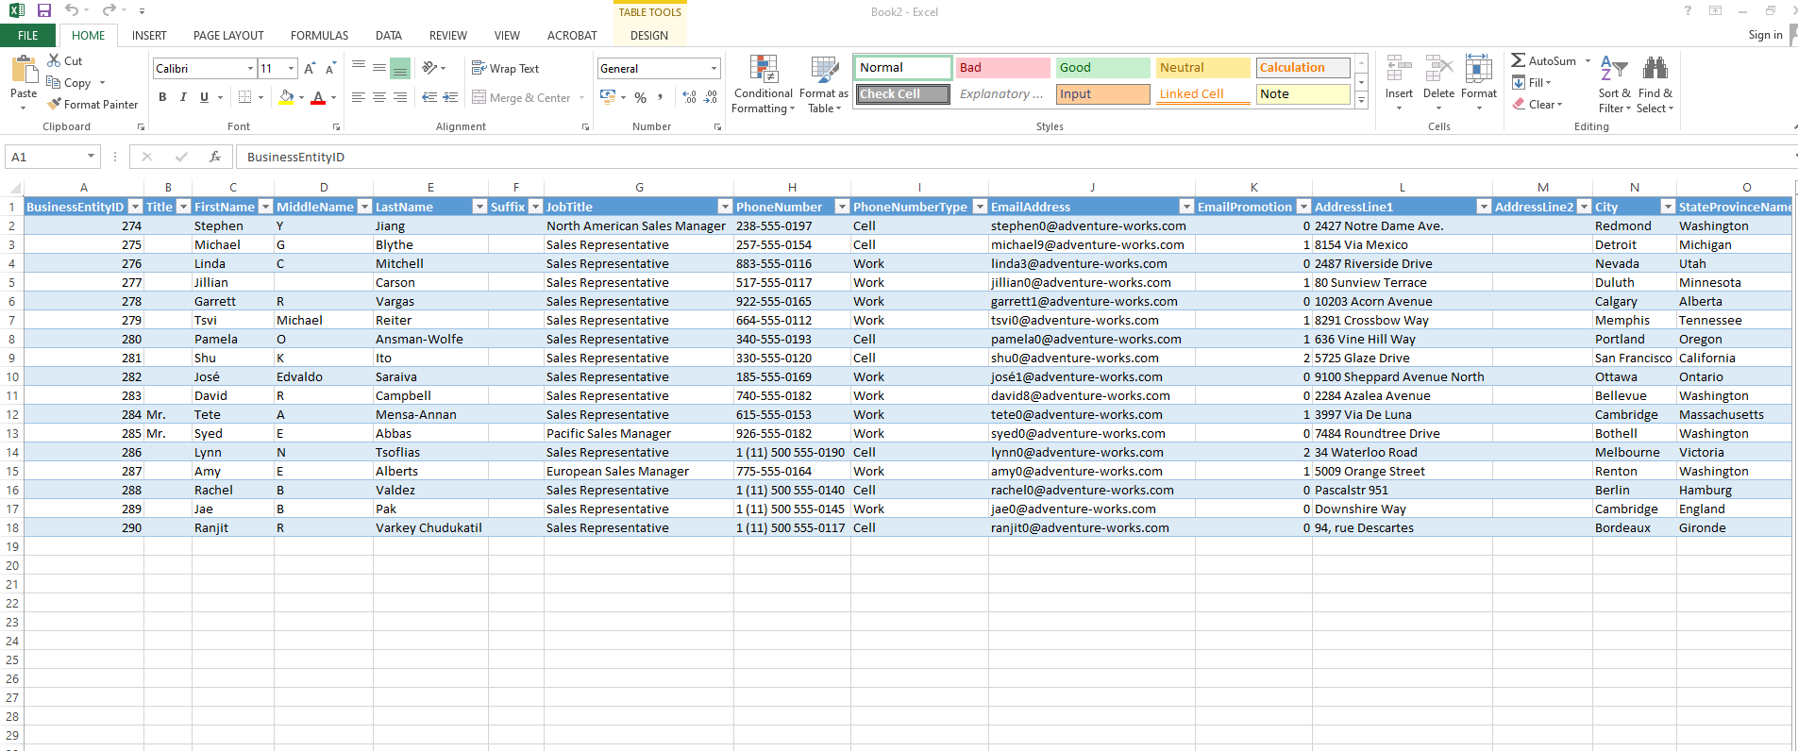

Practical 5B – Import the cube in Microsoft Excel and create the Pivot Chart to perform Data Modelling

The clustered column chart is shown with the selected database.

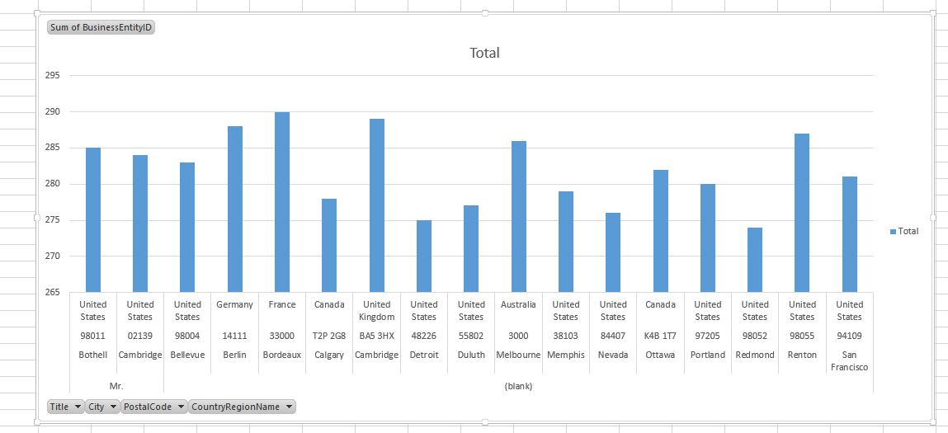

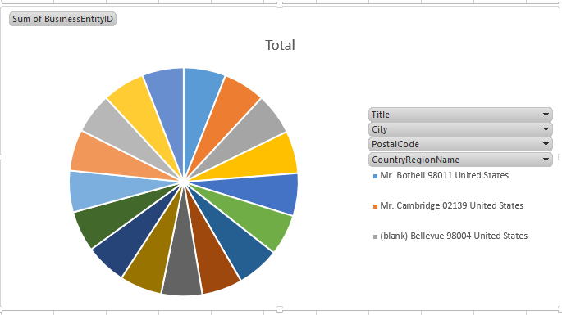

Name: Harshalk

Std: TYBSCIT

Roll no: 16

Subject: DMBI

(Practical No 6)

Signature:

Practical 6 – Perform the What-If Analysis for Data Visualization

Open Microsoft Excel. Create a table.

In Data tab, select Goal Seek under What-If Analysis.

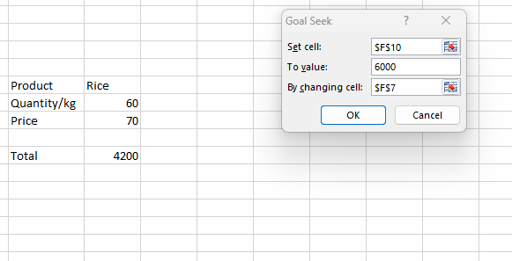

Enter the Set Cell value to where the changed value will be displayed. Enter the value that should be changed in To Value and the cell which should be changed in By changing cell.

Click on OK in Goal Seek Status.

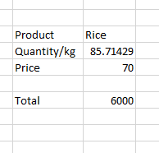

Select Data Table under What-If Analysis.

Enter the input cells and click on OK.

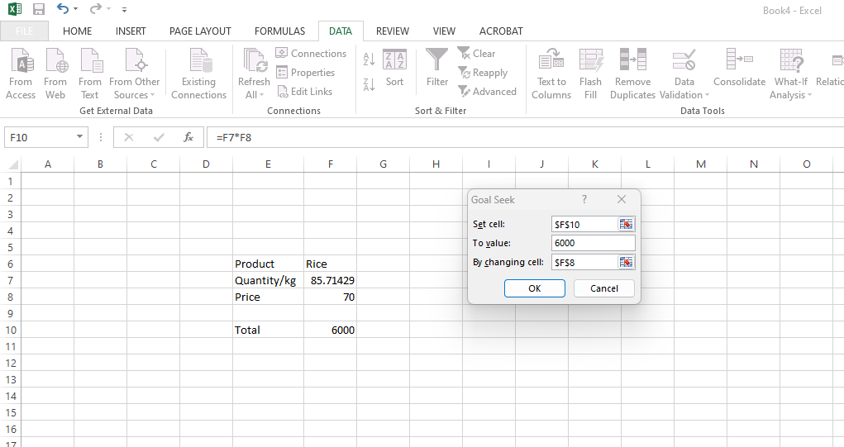

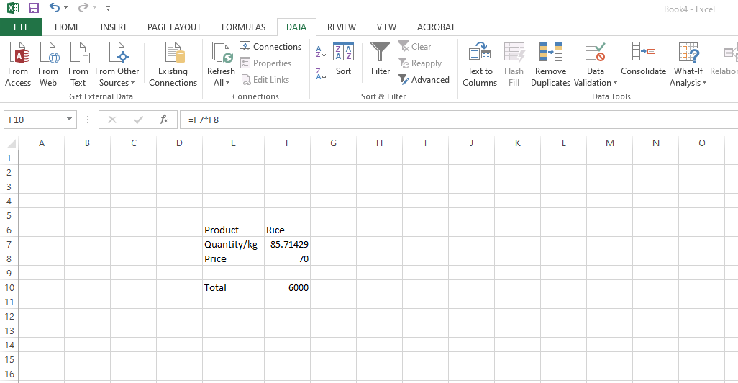

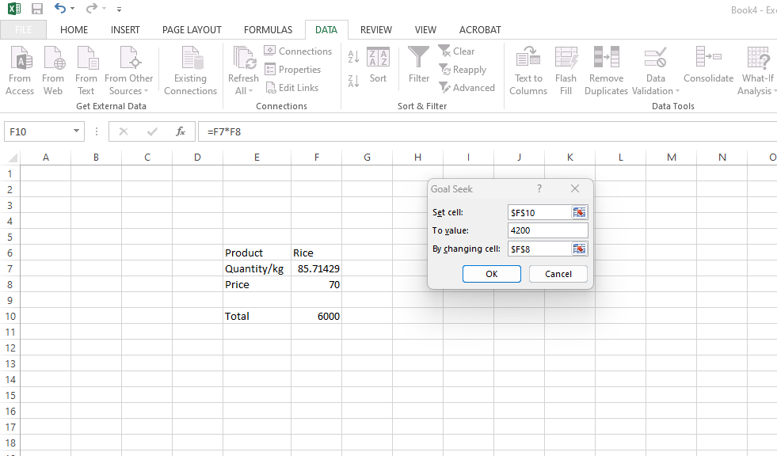

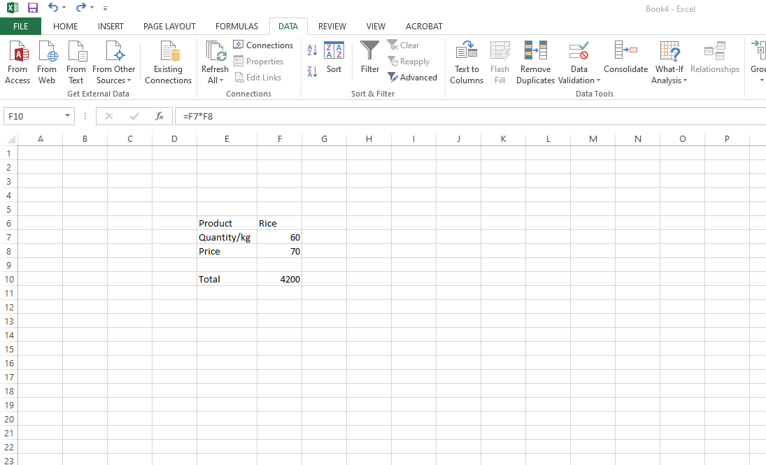

The result will be displayed.

